What can Austria and the Czech Republic learn from each other about supporting Photovoltaics?

Sandra Meier (Austria)
Petra Zíková (Czech Republic)

Co-operating Universities

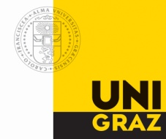

Financial support by

Prague and Vienna, 2010

Content
Content 2
1. Abstract 3
2. Motivation 3
3. Overview of PV Application Types 3
4. Overview of current situation in installed power 4
Austria 4
Czech Republic 5
5. Way of support 5
Austria 5
Czech Republic 9
6. Economic effectiveness 13
Austria 13
Czech Republic 13
8. Recommendation 14
9. Table of Figures 15
10. References 16

1. Abstract
Austria and the Czech Republic have different strategies concerning the support of Photovoltaics. In Austria some effort was done in the last years in the establishment and alteration of the Green Electricity Act, but the supporting scheme of Photovoltaics is non-transparent and hard to calculate and too less money is available so that Photovoltaics just contribute to a tiny part to the renewable electricity generation in Austria. The Czech Republic seems to have established a transparent and easy accessible supporting scheme as the Photovoltaics sector booms, but there it is too easy to get financial support, as investors start to make an advantage out of it and create a threat to the local electricity supply. Neither the Austrian system nor the Czech system is perfect, a recommendation can be a national-wide, transparent and accessible supporting scheme that hast to be monitored and limited to private households to guarantee a stabile and long-term growth of electricity generation out of Photovoltaics.

2. Motivation
Renewable Resources are very important for the future, as people start to realize that our common use of non-renewable resources cannot continue unlimited because of the scarcity of some resources and the realized phenomenon of climate change. A very important sector where changes in resource types have to happen is the electricity sector. One possibility for this sector is the creation of electricity out of solar power – so called Photovoltaics. But the change-over to such new technologies as Photovoltaics has to be supported by the state so that an incentive for the switch is created. But countries over the world handle the support different and so there are different effects of the supporting schemes in different countries. The Czech Republic and Austria are two countries where the supporting schemes are very different and so different effects can be expected. In our paper we discuss the topic of Photovoltaics and we try to compare the different financial supporting systems provided by the state in the two concrete EU-countries Austria and Czech R. We want to find out the advantages and disadvantages of the regulations in both countries and concentrate on the problems that are resulting. Considering the advantages of the different systems in the two countries, we try to give suggestions to another.

3. Overview of PV Application Types
Photovoltaic is the electricity generation from solar radiation by using photovoltaics modules. We distinguish two types of systems – grid-on and grid-off systems. Systems connected to the grid (grid-on systems) represent the majority of production. This is a classical situation where the owner of the PV system is connected to a public distribution network and adds the produced solar electricity to the grid. His earnings are the purchase price. Grid-off systems are not connected to the distribution network, the produced energy is just meant for the own consumption. Grid-off systems are used in places with poor accessibility, such as mountain huts or towers (Polednik in Sumava Mountains) (Protection Consulting, 2010).

 | Installed capacity (MWp) | Gross electricity generation (GWh) | Net electricity generation (GWh)
Photovoltaics | 39,5 (54,29) | 12,937 | 12,937
Figure 1: Solar Photovoltaics electricity generation in the Czech Republic in 2008 (Energy Regulatory Office, 2010)

4. Overview of current situation in installed power

Austria
In Figure 2 we see the development of the Photovoltaic market in Austria in the time range from 1992 – 2008. The red line (cumulative capacity) indicates that in 2008 a total capacity of about 33.000 kWpeak was installed in Austria. When we look at the development of the annually new installed capacity (orange bars), we can see that there was a maximum in 2003. The boom can be explained by really good incentives because of a new Green Electricity Act. After 2003 Austria realized a market break, as the Green Electricity Act was altered and since 2007 we experience a recovery in the Photovoltaic installation market because of new incentives given by the state (BMLFUW, 2009).

Figure 2: new installed PV application in kWp in Austria 1992 – 2008 (Biermayr et al. 2009 in BMLFUW, 2009)

When we look at the amount of electricity produced out of Photovoltaics in Austria compared with other renewable sources, we can see that Photovoltaics just holds a small portion of the whole. In 2008, about 43.000 GWh of electricity was produced through renewable resources, only 17 GWh are produced by Photovoltaics, as we see in Figure 3.

electricity
biomass (solid, liquid, gasous) | 2.489 GWh
geothermal energy | 2 GWh
water power | 38.868 GWh
photovoltaics | 17 GWh
wind energy | 1.988 GWh
total amount | 43.364 GWh
Figure 3: supply of final energy out of renewable resources for electricity production in Austria 2008 (BMLFUW, 2009)
Czech Republic
In 2004, the Czech Republic as the Member State of EU started with the reduction of the electricity generation out of fossil fuels and the promotion of the use of renewable sources. The share produced from RES (hydro, biomass, biogass, wind, photovoltaics) in the total gross final cosumption of the Czech Republic in 2010 should amount about 8 %. At the end of 2007 it was 4,74 %. Thus, in order that the expanded and Czech Republic could meet its commitment to provide subsidies to producers, the purchase price was fixed in advanced periods and helps to obtain favorable loans.

 | 2003 | 2004 | 2005 | 2006 | 2007 | 2008
Hydro power plants | 1 383 467 | 2 019 400 | 2 379 910 | 2 550 700 | 2 089 600 | 2 024 335
Biomass | 372 972 | 564 546 | 560 252 | 731 066 | 968 063 | 1 170 527
Biogas | 107 856 | 138 793 | 160 857 | 175 837 | 215 223 | 266 868
Wind | 3 900 | 9 871 | 21 442 | 49 400 | 125 100 | 244 661
Photovoltaics | 184 | 291 | 414 | 592 | 2 172 | 12 937
Figure 4: Gross electricity generation from RES (MWH) (Ministry of Industry and Trade, 2010)

5. Way of support

Austria
The supporting scheme for Photovoltaics in Austria is not easy to understand as it varies over time and over the different provinces. You can get financial support in the form of investment subsidies from the state, in some provinces and some communities, as well as feed-in tariffs. What is more, you can sell your electricity from your grid-in Photovoltaics to different electricity providers under different conditions and different prices.
Since 2010 you can ask for an investment subsidy out of the climate and energy fund for Photovoltaic applications with a peak load smaller than 5 kWpeak and a tariff-support from the OeMAG for applications with a peak load higher than 5 kWpeak (OeMAG, 2010).

Investment subsidies:

Climate and energy fund
Since 2008 the Austrian climate and energy fund provides investment subsidies for Photovoltaics as the Austrian government decided the 2020 rule, that means that until 2020 34% of the Austrian energy should be provided by renewables. A special focus on the support of Photovoltaics by the Austrian climate and energy fund was lead on building-integrated photovoltaics and modular homes.
In 2008 the fund provided 8 millions € for private households for the installation of photovoltaics to the maximal peak load of 5 kWpeak and 3 millions € for modular home producers for the production of modular homes with building-integrated Photovoltaics.
The climate and energy fund decided to continue with the investment subsidies at least until 2010 to avoid negative stop-and-go effects in the area of Photovoltaics (Klima- und Energiefonds, 2008).
In 2009 the climate and energy fund raised the support to 19 million for the Photovoltaics sector. 18 millions € were given to private households who decided to build a photovoltaic system, 1 million € was given to private households who decided to build a modular home with an building-integrated photovoltaics application. Higher subsidies were given to people who decided to build a building-integrated photovoltaic application compared to people who decided to build a photovoltaic system on the free land (Klima- und Energiefonds, 2009).
For 2010 it is planned to continue with the support, given a budget of about 35 millions €. Nothing clearly can be said now, as there are not any concrete aspects announced yet. What can be said is that the focus is led again on modular homes (Klima- und Energiefonds, 2010).

Investment subsidies in the provinces:
In the different provinces in Austria you can also get support for a new-installation of Photovoltaics. The provinces support private households.
In Figure 5 you can find an overview of the different subsidies in the different provinces in Austria in 2008. In 4 provinces you didn’t get any subsidy in 2008 whereas in Burgenland, Lower-Austria, Vorarlberg and Vienna you got some subsidy.
province | PV-support
Burgenland | investment subsidy for private PV-installation <10kWp
Carinthia | no investment subsidy in 2008
Lower-Austria | investment support out of the housing subsidy for private PV installation <5kWp
Upper-Austria | no investment subsidy in 2008
Salzburg | no investment subsidy in 2008
Styria | no investment subsidy in 2008
Tyrol | no investment subsidy in 2008
Vorarlberg | additional support to the support out of the climate and energy fund
Vienna | investment subsidy max. 2400 € per kWp
Figure 5: investment subisidies in the different provinces in Austria in the year 2008 (BMVIT, 2009)

Investment subsidy from the communities:
Also in some communities you can get an investment subsidy for the installation of a photovoltaic system. I picked some examples from the region Fürstenfeld in Styria (see Figure 6) where you can get in some communities an investment subsidy for the Photovoltaics installation.

community | support for PV application
Burgau | € 25/m²
Großwilfersdorf | € 400/application
Loipersdorf bei Fürstenfeld | 100%
Ottendorf an der Rittschein | € 25/m²
Söchau | € 50/m²
Figure 6: overview of actual communal subsidies for Photovoltaics for the area Fürstenfeld in Styria (LEV, 2010)

Tariff support

Nationwide tariff-support
The tariffs are regulated in the Eco-Electricity Act that was established 2002 and amended constantly the years after. Since the last amendment in 2008, that was realized in September 2009 it came to big changes in the supporting of tariffs in the area of Photovoltaics. Since 2010, an annually amount of 2.1 millions € is provided for feed-in tariffs compared to the years before, where 1.7 millions € were provided. Since the new amendment just Photovoltaics systems with a peak load higher than 5kWh are supported. The tariffs vary between different forms of applications.
Tariffs for photovoltaic applications on a roof and on noise-protection walls:
5 kWpeak – 20 kWpeak | 38 cent/kWh
> 20 kWpeak | 33 cent/kWh

Tariffs for photovoltaic applications not on a roof and not on noise-protection walls:
5 kWpeak – 20 kWpeak | 35 cent/kWh
> 20 kWpeak | 25 cent/kWh

The duration for the tariff is for 13 years (PVAustria, 2010).
In Figure 7 you can see an overview of the feed-in amounts and feed-in tariffs paid from the OeMAG in 2008.
Eco-Electricity in Austria
2008 | feed-in amount in kWh | net compensation in € | average tariff in cent/kWh
small hydropower | 944.831.271 kWh | 53.091.460,43 | 5,62
others | 4.495.600.684 kWh | 523.094.402,59 | 11,64
wind power | 1.987.942.797 kWh | 154.803.507,49 | 7,79
solid biomass | 1.900.045.138 kWh | 258.536.726,48 | 13,61
biogas | 502.770.622 kWh | 89.019.230,26 | 17,71
liquid biomass | 35.781.357 kWh | 6.336.076,59 | 17,71
photovoltaics | 17.331.157 kWh | 10.407.031,91 | 60,05
landfill gas | 50.113.775 kWh | 3.811.586,66 | 7,61
geothermal energy | 1.615.839 kWh | 180.243,21 | 11,15
total | 5.440.431.955 kWh | 576.185.863,02 | 10,59
Figure 7: overview of eco-electricity in Austria 2008 (OeMAG, 2010)

Selling electricity on the market
If you produce more electricity than you need, you can sell your electricity to different electricity providers. In Figure 8 you can find some examples of electricity providers that buy your electricity under different conditions and different tariffs (PVAustria, 2010).
.

company | tariff/kWh | adaption to the development of the market price | commitment | special conditions
EVN | 8,27 ct | annually | 10 years | - customer of EVN  - installation of application by EVN-partners  - installation until 31.12.2009
Steweag-Steg GmbH | 15 ct | fixed for 2 years | 2 years | - just for customers of the product „select“  - just for Styria
Verbund | 10 ct | occassionally | no | - customer of Verbund  - installation of application by an Verbund-partner  - € 6 or € 10 basic charge
Figure 8: examples of feed-in tariffs for electricity produced out of Photovoltaics (PVAustria, 2010)

Czech Republic

Legislation
The purpose of Act No. 180/2005 Coll. Act on the promotion of renewable energy sources is to promote the use of renewable energy sources (wind, solar radiation, biomass, water, geothermal, etc.), to ensure a steady increase in the share of renewables in the consumption of primary energy sources, contribute to the sound use of natural resources and sustainable development of society, establish the conditions for realizing the objective share of electricity from renewable sources in gross electricity consumption in the Czech Republic in the rate of 8% by 2010 and create conditions for further increasing this share by 2010.
Through this Act, grid distributors (for example: PRE, E.ON, CEZ) are legally obliged to use all the energy produced. The purchase price is set by the Energy Regulatory Authority and guaranteed as a minimum for the period of next 20 years.

Support
The Czech Republic is using for the support of solar electricity generation the mechanisms of forpurchaseprice (feed-price) and green bonuses. Green bonus is a financial amount, increasing the market price of electricity because there is no degradation of the environment.
For example for PV put into operation in 2009, the following prices: for solar power to 30 kW is set at CZK 12,89 per 1 kWh (green bonus of CZK 11,91 per 1 kWh) where the installed capacity of solar power 30 kWh, then the purchase price set at CZK 12,79 per 1 kWh (green bonus of CZK 11,81 per kWh). In our example with a family house, it is clear that owning a solar power pays off. The purchase price is approximately three times higher than the price at which 1 kWh of electricity is bought by households.

Consuption electricity | Payment for annual consumption
5000 kWh/year | 22 750,- CZK/year | 4,55 CZK/kWh
Figure 9: Family house without PV systém (Protection Consulting, 2010)

Family house with PV systém (located near Brno)
Consumption electricity from local network |  | Own consuption of electricity |  | Electricity produced/year
2600 kWh/year |  | 2400 kWh/year |  | 5057 kWh/year
11 830,- CZK | 4,55 CZK/kWh | 10 920,- CZK | 4,55 CZK/kWh | 62 776,- CZK | 12,41 CZK/kWh
PAY |  | PAY NOT |  | GET
Figure 10: Family house with PV sytem (near Brno) (Protection Consulting, 2010)

Originally, the purchase prices are set to allow a return out of the business investment in PV in fifteen years. However, cheaper and more efficient pannels allow a return within seven years. But the technology is constantly improving, so the return is expected to increase soon. This would lead to this outrageous development field, where the entrepreneurs can earn incredible. According to EPIA, PV development also benefits the uncomplicated administration, which precedes the construction of power plants.

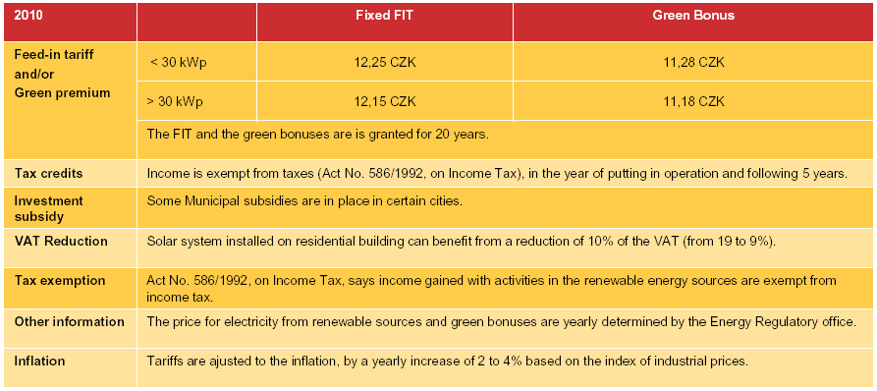
Figure 11: National Support Schemes – Czech Republic (EPIA, 2010)

In Figure 12 you can see the interesting increase in the production of energy by photovoltaic systems between 2007 and 2008. The highest percentage of increase is 514 %, but in terms of the total volume of electricity this only meant an increase of 10,8 GWh. This giant percentage increase was caused by a significant fall in investment costs (40%) and the existence of profitable purchase prices.

Figure 12: Gross electricity generation of PV (Ministry of Industry and Trade), 2010

At the end of 2008 over 1200 licences were issued, total installed capacity was over 54 MWp. The largest photovoltaic power plan that launched in 2008 was the Dívčice. On the area of 12 ha, 40 000 panels producing 2,9 MWp were installed. Most common systems are up to 5 kWp or 3 kWp.

In such good conditions we can find many well-established companies specializing just on solar power. The following tables show the projects of the largest companies in the past few years.

Energy 21
Run in 2009 | Electricity generation |  | Run in 2008 | Electricity generation
Určice 2 | 2,14 MW |  | Velký Karlov | 0,35 MW
Micmanice | 1,14 MW |  | Krhovice | 0,50 MW
Chropyně | 1,07 MW |  | Dívčice | 2,90 MW
Rozvadov | 2,20 MW |  | Vojkovice | 0,60 MW
Protivín 2 | 0,60 MW |  | Hrádek | 1,10 MW
Litenčice | 0,84 MW |  | Jaroslavice | 0,65 MW
Netolice | 2,46 MW
České Velenice | 1,50 MW
Určice 1 | 0,96 MW
Velká n. Veličkou | 0,36 MW
Jaroslavice 2 | 0,49 MW
Hrušovany nad Jeviškou | 2,10 MW
Protivín 1 | 3,00 MW
Figure 13: Photovoltaics power stations Energy 21 a.s. (Energy 21, 2010)

HiTech Solar s.r.o
Run in 2009 | Electricity generation |  | Run in 2008 | Electricity generation
Ostrožná Lhota | 2,33 MWp |  | Bystřice n. Hostýnem | 0,25 MWp
Buchlovice | 1,00 MWp |  | Kunčina | 0,25 MWp
Stupešice | 0,68 MWp |  | Osvětimany | 0,12 MWp
Kutná Hora | 0,48 MWp |  | Moravské Budějovice | 0,10 MWp
Udánky | 0,38 MWp
Figure 14: Photovoltaics power stations HiTech Solar s.r.o. (HiTech Solar, 2010)

Sluneta s.r.o
Run in 2009 | Electricity generation |  | Run in 2007 or 2008 | Electricity generation
Ratíškovice | 2,20 MWp |  | Dubňany 1 | 0,66 MWp
Ústí nad Labem | 0,035 MWp |  | Dubňany 2 | 2,20 MWp
Dubňany 3 | 1,14 MWp
Olešná | 0,66 MWp
Figure 15: Photovoltaics power stations Sluneta s.r.o. (Sluneta, 2010)

6. Economic effectiveness

Austria
The comparison with other countries concerning the annually new installed capacity shows that Austria just plays a tiny part. But Austria is ahead in the production of the photovoltaic modules – 99% of the produced modules are exported to other countries. The problem is that the general conditions that led to the flourishing photovoltaic markets in Germany, Spain and the Czech Republic, are not given in Austria yet. The Austrian supporting system is very complex, differs regionally and is hard to calculate. Compared to other countries, the supporting amount is too small. Further, the multilateral structures and high number of different subsidies lead to high administrative costs and create barriers on the photovoltaic market. The costs could be mitigated through the creation of one supporting strategy on the state-level. And what is more, the administrative costs could be used for additional supporting, which would lead to a positive economic effect (BMVIT, 2009).
A big problem is the fact, that too less money is available for the support of Photovoltaics. The tariff-support for the year 2010 was already exploited in January 2010. The list of new applicants for the tariff-support is so long that also the amount that will be supplied for the year 2011 is already exhausted (PVAustria, 2010).

Czech Republic
The problem is that very profitable purchase prices are attractive for investors and speculators. Their great interest in photovoltaics affects negatively other renewable energy sources. The costly incentive system to purchase power has also led to significant price rises for energy consumers. The boom of Photovoltaics is sometimes mentioned in connection with “blackout”. These are reasons why Czech representatives prepared changes in the system of supporting PV.
Blackout means a short- or long-term loss of the electric power of an area. (Wikipedia, 2010) CEPS, company for electricity transmission in CR, asked all distributors (CEZ, PRE, E.ON) to outsource additional authorization. A huge number of new power plants could cause the blackouts. This measure can be criticized for it, that the prohibition applies to both large and small operators of photovoltaic systems, although the roofs of houses with a few panels for the stability of the network do not cause any danger.
Changes are in the calculation of purchasing prices. According old conditions they could fall by up to 5 percent. Actually they may decrease by up to 35 percent (pay for power plants put into operation in 2011). Banks are likely to limit the range of concessional loans. Speculative investment in PV will no longer be so certain and return again back to 11 years. (Honsová, 2010)

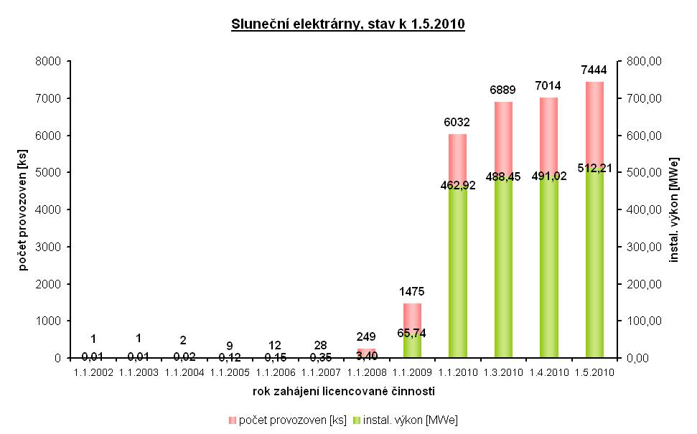
Figure 16: Photovoltaics power stations, state on 1.5.2010. (ERU, 2010)

8. Recommendation

When we compare the different supporting systems in Austria and the Czech Republic we can come to the conclusion that each of the systems has its advantages and disadvantages. The most obvious thing is that neither in Austria nor in the Czech Republic the supporting system is perfect. Whereas in Austria you have too much demand for support and too less money available in a complex, non-transparent supporting scheme on different levels, in the Czech Republic financial support is to easy to get and creates the problem of exploitation by investors that seek for high returns and risk problems in the electricity supply of areas.
Maybe it would be useful to create a supporting system that is a mix of the two schemes. It seems to be advantageous to create one supporting scheme on a national-level that is transparent and accessible but monitored by the state and limited to private households.

Supporting scheme must be:
- legal
- transparent
- accessible and simple
- flexible to changes in market
- one on a national level
- adequate
Figure 17: conditions for a good supporting scheme (authors themselves)

9. Table of Figures
Figure 1: Solar Photovoltaics electricity generation in the Czech Republic in 2008 (Energy Regulatory Office, 2010)
Figure 2: new installed PV application in kWp in Austria 1992 – 2008 (Biermayr et al. 2009 in BMLFUW, 2009)
Figure 3: supply of final energy out of renewable resources for electricity production in Austria 2008 (BMLFUW, 2009)
Figure 4: Gross electricity generation from RES (MWH) (Ministry of Industry and Trade, 2010)
Figure 5: investment subisidies in the different provinces in Austria in the year 2008 (BMVIT, 2009)
Figure 6: overview of actual communal subsidies for Photovoltaics for the area Fürstenfeld in Styria (LEV, 2010)
Figure 7: overview of eco-electricity in Austria 2008 (OeMAG, 2010)
Figure 8: examples of feed-in tariffs for electricity produced out of Photovoltaics (PVAustria, 2010)
Figure 9: Family house without PV systém (Protection Consulting, 2010)
Figure 10: Family house with PV sytem (near Brno) (Protection Consulting, 2010)
Figure 11: National Support Schemes – Czech Republic (EPIA, 2010)
Figure 12: Gross electricity generation of PV (Ministry of Industry and Trade), 2010
Figure 13: Photovoltaics power stations Energy 21 a.s. (Energy 21, 2010)
Figure 14: Photovoltaics power stations HiTech Solar s.r.o. (HiTech Solar, 2010)
Figure 15: Photovoltaics power stations Sluneta s.r.o. (Sluneta, 2010)
Figure 16: Photovoltaics power stations, state on 1.5.2010. (ERU, 2010)
Figure 17: conditions for a good supporting scheme (authors themselves)

10. References

Abwicklungsstelle für Ökostrom AG (OeMAG) (2010), Download on 14.04.2010 from http://www.oem-ag.at/

Bundesministerium für Land- und Forstwirtschaft, Umwelt und Wasserwirtschaft (BLFUW) (2009), Erneuerbare Energien in Zahlen. Download on 13.04.2010 from http://publikationen.lebensministerium.at/publication/publication/view/3210/28601

Bundesministerium für Verkehr, Innovation und Technologie (BMFIT) (2009), Erneuerbare Energien in Österreich – Marktentwicklung 2008. Download on 25.04.2010 from http://www.nachhaltigwirtschaften.at/nw_pdf/0916_marktstatistik_erneuerbare_energien_2008.pdf

CEZ GROUP, Solar energy. Download on 20.04.2010 from http://www.cez.cz/cs/vyroba-elektriny/obnovitelne-zdroje/slunce/informace-o-slunecni-energetice.html

Honsová, M.: Spekulanti mizí ve stínu. Ekonom č. 23

European Photovoltaic Industry Assotiation (EPIA), Overview of National Support Schemes (PDF) Download on 19.05.2010 from http://www.epia.org/policy/national-policies.html

Energy 21, Projects. Download on 20.04.2010 from http://www.energy21.cz/projects-232/

Energy Regulatory Office (ERU). Download on 20.05.2010 from http://www.eru.cz/dias-browse_articles.php?parentId=113

HiTech Solar, Projets. Download on 20.04.2010 from http://www.hitechsolar.cz/

Klima- und Energiefonds (2008), Jahresprogramm 2008. Download on 28.04.2010 from http://www.klimafonds.gv.at/fileadmin/media_data/Dateien/jahresprogramm_screen.pdf

Klima- und Energiefonds (2009), Jahresprogramm 2009. Download on 28.04.2010 from http://www.klimafonds.gv.at/fileadmin/media_data/Dateien/publikationen/Jahresprogramm_2009/jahresprogramm_screen_endversion.pdf

Klima- und Energiefonds (2010), Jahresprogramm 2010. Download on 28.04.2010 from http://www.klimafonds.gv.at/fileadmin/media_data/Dateien/downloads/Jahresprogramm_2010/Jahresprogramm_2010_Klima-_und_Energiefonds.pdf

Landesenergieverein Steiermark (LEV) (2010), Gemeindeförderungen. Download on 28.04.2010 from http://www.lev.at/

Ministry of Industry and Trade of the Czech Republic, Renewable source of energy. Download on 20.04.2010 from http://www.mpo.cz/dokument64916.html

Photovoltaic Austria Federal Association (PVAustria) (2010). Download on 28.04.2010 from http://www.pvaustria.at

Protection Consulting, How does Photovoltaics works. Download on 20.04.2010 from http://www.protection.cz/how-does-photovoltaic-power.html?id=75&ln=en

Raiffeisenbank, Helios. Download on 19.05.2010 from http://www.rsts.cz/pujcky-na-bydleni/preklenovaci-uvery/uver-helios.aspx

Sluneta, Projects. Download on 20.04.2010 from http://sluneta.webnode.cz/

Wikipedia, Blackout. Download on 11.05.2010 from wikipedia.org/wiki/Power_outage

For example financial product by Raiffeisen Bank Hellios. This loan is specifically designed for the financing of a photovoltaic system. To investors offer next benefits: option to defer payments for up to 6 months, ability to use state aid in building savings to 3000,- CZK per year, the bank will provide loans of up to 500 000,- CZK without guarantee of real estate, etc.

